

Polk County Infant-Toddler Court
Program: Local Evaluation Report
(April, 2026)

f

the
National Resource Center
for
Family Centered Practice

National Resource Center for Family Centered Practice
Consortium for Substance Abuse Research and Evaluation
The University of Iowa School of Social Work
110 MTP-4 Iowa City, Iowa 52242-5000
Phone: 515.235.4005; 515.771.3589
Web site: https://nrcfcp.uiowa.edu/



Acknowledgements

Suggested Citation:
Conrad, A., Strack, S. (2026). Polk County Infant-Toddler Court Program: Local Evaluation Report. Iowa City, IA:
University of Iowa Consortium for Substance Abuse Research and Evaluation.
Retrievable at: http://iconsortium.subst-abuse.uiowa.edu/

Project Director, Rhonda Rairden-Nelson, LMSW, IECMH-E
Division of Family Well-Being and Protection
Iowa Department of Health and Human Services
321 E. 12th St., Des Moines, IA 50319
515-201-6204
rhonda.rairden-nelson@hhs.iowa.gov
HHS.Iowa.gov

Authors:
Evaluation and Data Lead, Aislinn Conrad, LMSW, PhD, Associate Professor
The University of Iowa, School of Social Work
Consortium for Substance Abuse Research and Evaluation
aislinn-conrad@uiowa.edu

Sarah Strack, MPH
The Center for Public Health Evaluation and Research
National Resource Center for Family Centered Practice
Phone: 319-335-4930
sarah-strack@uiowa.edu
Website: https://pubhealtheval.org.uiowa.edu
https://icsa.uiowa.edu/

Principal Investigator, Brad Richardson, PhD, Research Scientist
National Resource Center for Family Centered Practice
Consortium for Substance Abuse Research and Evaluation
brad-richardson@uiowa.edu
515.771.3589 (cell), 515-235-4005 (office)
Website: https://nrcfcp.uiowa.edu/
https://icsa.uiowa.edu/

Disclaimer and Acknowledgement: This project was partially supported by the U.S. Health Resources and Services Administration (HRSA) through a contract with the Iowa Department of Health and Human Services (CFDA No. 93.110; Grant No. U2ZMC46644) and state contract with University of Iowa FWBPCPSSFY25111. Partial support is also provided by the National Center for Advancing Translational Sciences of the National Institutes of Health under Award Number UL1TR002537. The content is solely the responsibility of the authors and does not necessarily represent the official views of HRSA, the National Institutes of Health, Iowa Dept. of Health and Human Services or The University of Iowa.

TABLE OF CONTENTS
INTRODUCTION 4
Survey Respondent Characteristics 7
Trauma-Responsive and Evidence-Based Practices 8
State Leadership 16
ITCP Permanency Outcomes 21
CONCLUSIONS AND RECOMMENDATIONS 23
List of figures
Figure 1. Trauma-Responsive Practice 10
Figure 2. Evidence-Based Practices 11
Figure 3. I encounter barriers when trying to implement… 12
Figure 4. Do you believe there are sufficient resources available to implement...? 13
Figure 5. Do you believe that Safe Babies has improved your professional skills? 14
Figure 6. Workforce Representation and Recruitment Survey Results 18
Figure 7. Applicant Outreach and Workforce Capacity Survey Results 19
Figure 8. Equity in Family Participation Survey Results 20
Figure 9. Perceived Leadership Support Survey Results 22
List of Tables
Table 1. What types of evidence-based and/or trauma-responsive practices do you use in working with ITCP? 15
Table 2. What barriers do you encounter when implementing trauma-responsive or evidence-based practices? 16
Table 3. What areas should trauma-informed trainings focus on to address your professional needs? 17
Table 4. Who determines which families participate in Safe Babies? 20
Table 5. Permanency Outcomes by Reason for Removal 23

INTRODUCTION
The Infant-Toddler Court Program (ITCP) is designed as an intervention and community collaborative approach designed to advance family centered policies and systems to prevent and reduce involvement in public child welfare. Core components include a judge to champion the model, a full‑time Community Coordinator, an active interdisciplinary team of community partners (e.g., child welfare case managers, community coordinator, attorneys, early childhood providers), commitment to data collection, evaluation and continuous quality improvement, rapid service access, systems level collaboration at the state and local levels, and training and support from the Zero To Three National Resource Center.
Overall, the approach involves employing trauma-informed principles and early childhood best practices to provide children with stable, nurturing, supportive and healthy environments. Intensive services are coordinated to support individual family needs, promote early childhood development, and well-being. Formal goals include reducing the time young children spend in foster care, increasing family stability, and promoting achievement of positive developmental outcomes (Joseph et al., 2023).
As part of the commitment to data collection, evaluation and continuous quality improvement, the University of Iowa School of Social Work, National Resource Center for Family Centered Practice, the local implementation team and the Iowa Department of Health and Human Services (Iowa HHS, state administrative agency), have collaborated to conduct a local evaluation of the Safe Babies approach in Polk County, Iowa. The specific aims of the evaluation are to assess the effectiveness of the approach for: 1) in improving family reunification rates and thereby reducing the rate of termination of parental rights, 2) promoting trauma-informed practices, and 3) increasing access to services for families and children to meet their needs. In addition, the evaluation examines reasons for removal for closed cases during the evaluation period, use of trauma-informed and evidence-based practices, representation and recruitment pathways in the ITCP workforce, variation in family participation, and barriers to implementation including workforce capacity and resource sufficiency.
To evaluate effectiveness at the case level, demographic data, services provided, and permanency indicators are recorded in an electronic data system for ongoing evaluation. In addition, data are collected from the community ITCP professionals using two data collection strategies; results of that effort is the focus of this report. Findings from this mixed-methods analysis are intended to inform continuous quality improvement efforts, support state-level planning and decision-making, and contribute to broader efforts to strengthen infant-toddler court programming and improve public child welfare outcomes.
- State Leadership and Advisory Team Feedback Sessions and Survey
Data were collected through an embedded in-meeting evaluation process during the State Advisory Leadership Team (SALT) meeting on October 22, 2025. Participants completed a brief six-item Likert survey (n = 13) followed by structured small-group breakout discussions corresponding with key research questions related to workforce, outreach and family participation. This interactive format was implemented to engage participation and generate richer qualitative information leading to enhanced understanding and insight from the mixed methods approach.

- Trauma-Informed Practices Survey
An electronic survey was administered to ITCP stakeholders in all participating collaborative agencies in Polk County, Iowa, during a two-week period in October 2025 (October 11 to October 29, 2025). Eighteen (18) completed the Likert-scale section assessing trauma-responsive practices, evidence-based practice implementation, training, organizational support, and resource sufficiency. Open-ended responses were gathered to gain a more complete understanding of barriers and professional development needs.
Data Sources, Measures and Analysis Plan
This part of the program evaluation employs a mixed-methods approach, combining quantitative data from surveys and case-level information gathered through an electronic data system with additional insights gained through obtaining qualitative and quantitative information from community stakeholders. Key questions guiding the analysis include:
- Trauma-Informed Practices & Implementation
  - To what degree are ITCP professionals utilizing evidence-based and/or trauma-informed practices in their work?
  - What barriers and facilitators do professionals encounter when implementing these practices?
  - What specific areas should future trauma-informed training programs focus on to better meet the needs of ITCP professionals in serving child welfare clients?
- Workforce Representation
  - What factors influence the recruitment, selection, and advancement of individuals within the ITCP?
  - What strengths, challenges and opportunities exist for increasing representation among the ITCP workforce and strengthening outreach?
- Family Participation
  - What factors are considered when determining eligibility and participation of families in ITCP?
  - To what extent is the eligibility, referral and engagement process clear and consistent?
  - What family characteristics are associated with various levels of engagement and outcomes.
Survey Measures
The State Leadership and Trauma-Informed Practices data collection tools included Likert-scale items, yes/no questions, and open-ended responses designed to capture the perspectives of ITCP stakeholders and leadership.
In 2025, leadership data collection was embedded into a structured State Advisory Leadership Team (SALT) meeting and included both a brief six-item Likert survey and facilitated small-group discussions aligned with evaluation research questions.
Survey and focus group measures focused on:
- The frequency, confidence, and organizational support related to trauma-informed and evidence-based practices
- Perceived barriers and resource sufficiency for implementation
- Workforce diversity, recruitment pathways, and hiring
- Criteria and processes for family participation in ITCP
- Stakeholder experiences with training, leadership support, and interagency collaboration
Sample
The sample for the September 30, 2024 – September 29, 2025, period included:
- State Leadership Team Members: Individuals providing strategic direction and oversight for ITCP in Iowa who participated in the October 22, 2025, SALT feedback session (n = 13 survey respondents, with additional qualitative input from breakout discussions).
- ITCP Stakeholders: Professionals from agencies serving ITCP families in Polk County, including judges, attorneys, child welfare workers, therapists, and community coordinators (n = 31 survey respondents; n = 18 completed Likert-scale items).
- Case-level data are also presented for families served during the evaluation period.
Survey Protocol
The Trauma-Informed Practices Survey was distributed electronically to ITCP stakeholders on October 11 and October 29, 2025. Participation was voluntary, and responses were collected anonymously.
The State Advisory and Leadership Team data collection was conducted during the October 22, 2025, SALT meeting using an embedded evaluation model. Leadership participants completed a brief electronic survey during the meeting and then engaged in structured small-group discussions to generate qualitative insights aligned with workforce representation, outreach, and family participation research questions for the FFY 2025 evaluation period.
Analysis
Survey data were analyzed using descriptive statistics to examine frequency distributions and response patterns across Likert-scale items. Open-ended survey responses and leadership focus group notes were analyzed using thematic coding to identify recurring themes related to workforce capacity, trauma-informed practice implementation, resource sufficiency, and eligibility processes.
Findings were triangulated among survey responses, focus group discussions, and case-level data to strengthen interpretive validity and inform continuous quality improvement efforts.

Survey Respondent Characteristics
Members of the ITCP participated in two data collection efforts during October 2025: a State Leadership feedback session conducted on October 22, 2025, and a Trauma-Informed Practices Survey distributed electronically on October 11 and October 29, 2025.
A total of forty-four individuals engaged in the evaluation process, including 13 State Leadership respondents and 18 stakeholder respondents. These respondents represent a range of professional and organizational perspectives relevant to ITCP implementation. State leadership respondents included representatives from the Iowa Department of Health and Human Services, including the Child Protection, Family Well-Being and Protection division, the Iowa Courts, the University of Iowa, and other various local partner organizations. Stakeholder respondents were primarily legal professionals including attorneys (county and children’s) and judges, child welfare workers, therapists, counselors, CASAs, child welfare supervisors, and community navigators and social work professionals.
Among stakeholder respondents, legal professionals were the largest group with ten (10) respondents identified as attorneys or judges (56%), five (5) identified as helping professionals including child welfare workers, therapists, counselors, CASA, and community-based social service roles (28%), and two (2) identified as supervisors (11%). One stakeholder respondent did not report a professional role. Compared to FY2024, the FY2025 sample was similar with strong representation from legal and child-serving professionals.
Years of involvement in ITCP varied across respondents, with representation from individuals newly engaged in the ITCP approach as well as those with many years of experience. This range of tenure provided both historical system perspective and insight from newer participants regarding training, implementation, and referral processes. Some respondents (n = 8, 44%) indicated that they had been involved with ITCP for five or more years which is similar to FY2024 (42%). Others reported involvement of three to four years (n = 2, 11%), one to two years (n = 4, 22%), and one year or less (n = 3, 17%); one individual did not respond to the question (n=1, 6%).

Trauma-Responsive and Evidence-Based Practices
Trauma-responsive practice is an adaptive, nonpunitive approach to meet the unique needs of individuals with trauma (Zero to Three, 2020). These practices may include implementing routines and clear expectations, reflective supervision, along with clinical therapies like PCIT, EMDR, and Play Therapy. Evidence-based practices are interventions with research evidence regarding outcomes (Zero to Three, 2020).
In 2025, 18 stakeholders completed the Trauma-Informed Practices Survey. All eighteen (18) respondents completed the Likert-scale section assessing frequency, confidence, training, and organizational support related to trauma-responsive and evidence-based practices. Nearly all survey respondents (n=16, 89%) reported having previous experience using trauma-responsive or evidence-based practices.

To what degree do ITCP professionals utilize evidence-based and trauma-responsive practices in their work?
Respondents answered four questions about their use of trauma-responsive practices (Figure 1) and four questions about their use of evidence-based practices (Figure 2). Each set of questions asked respondents to rate their agreement with statements about:
- How often they use these practices
- Their confidence in using these practices
- Training received on these practices
- Organizational support for the use of these practices

Trauma-Responsive Practices
Figure 1 demonstrates responses to the four trauma-responsive practice questions. The majority of respondents reported frequent use of trauma-responsive practices (89% agree or strongly agree) and high confidence in applying those practices (89%). Seventy-eight percent reported having received adequate training, and 83% indicated that their organization supports trauma-responsive approaches.

Figure 1. Trauma-Responsive Practice

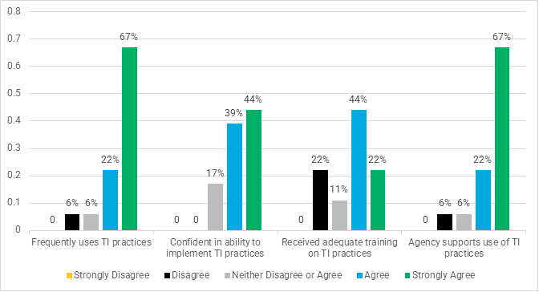

These findings suggest sustained integration of trauma-responsive principles across participating agencies and continued organizational alignment with trauma-informed values.
Compared with FY2024, FY2025 findings suggest continued consistent and ongoing in high levels of reported frequent use, confidence, training, and organizational support of trauma-responsive practice. Although the FY2025 report presents these findings in greater detail, the overall pattern remained consistent with FY2024, when most respondents also agreed with all trauma-responsive practice items.

Evidence-Based Practices
Figure 2 demonstrates responses to the four evidence-based practice questions. In FY2025, agency support and training on evidence-based practices remained strong compared to those obtained in FY2024, with 89% of respondents agreeing or strongly agreeing that they had received adequate training and that their agency supported the use of evidence-based practices.

Figure 2. Evidence-Based Practices
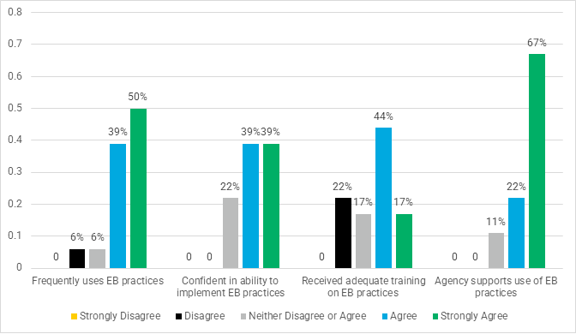
Adequate training was reported by 70% in FY2024 and 61% in FY2025. Agency support for the use of evidence-based practices was at 96% in FY2024, and 89% in FY2025. The proportion of respondents reporting frequent use of evidence-based practices was 89% in FY2025, and confidence in implementing evidence-based practices in FY2025 was 78%.
Taken together, these findings suggest that frequent use of evidence-based practices, confidence in implementing them, and agency supports are reported to be relatively strong. The lowest percentage of agree and strongly agree (61%) was for training on evidence-based practices. Access to training may be constrained by factors such as available agency resources and capacity to support training, workforce strain, and caseload and complexity (Connell et al., 2016).

What barriers and facilitators do ITCP professionals encounter when implementing trauma-responsive and evidence-based practices?
Respondents were asked about the extent to which they encounter barriers when implementing trauma-responsive and evidence-based practices and whether sufficient resources are available to support implementation (Figure 3). Nearly 40% of respondents agreed or strongly agreed with both statements.
Figure 3. I encounter barriers when trying to implement…
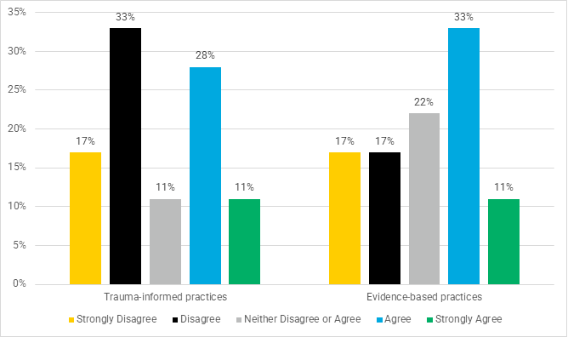
Responses regarding barriers were mixed. Some respondents reported encountering barriers when attempting to implement trauma-responsive and evidence-based approaches, while others indicated they encountered few challenges. This variability reflects differences in professional roles, service availability, and case complexity among agencies.
When asked whether they believe there are sufficient resources available to implement trauma-responsive practices, most respondents indicated “yes” (n=14, 78%). Fifty percent (50%, n=9) of respondents reported that there are sufficient resources available to implement evidence-based practices, as presented in Figure 4, below.
Compared to FY2024, perceptions of resource sufficiency was greater in the FY2025 sample. The proportion of respondents who reported sufficient resources for trauma-responsive practices (see Figure 4) was 57% in FY2024 compared to 78% in FY2025. The proportion reporting sufficient resources for evidence-based practices was 39% in FY2024 compared to 50% in FY2025. Despite this difference, only half of respondents in FY2025 reported that sufficient resources were available to implement evidence-based practices suggesting that resource constraints represent a meaningful barrier.
These findings also suggest that while knowledge, training, and organizational support for trauma-responsive and evidence-based practices is strong, structural constraints—such as provider shortages, workforce turnover, time demands, and case complexity—may limit consistent implementation.
Figure 4. Do you believe there are sufficient resources available to implement...?
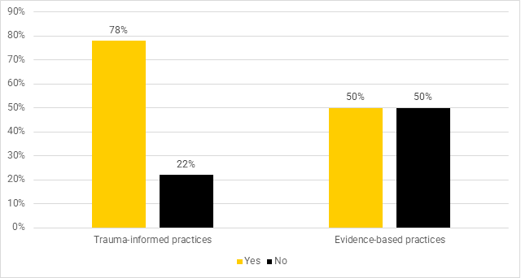

Do ITCP professionals feel that Safe Babies has improved their professional skills?
Stakeholders were asked whether participation in Safe Babies has improved their professional skills. Almost all respondents (n=17, 94%, see Figure 5, below) reported that involvement in Safe Babies contributed positively to their professional growth and understanding of trauma-responsive and collaborative practices. During FY2024, 61% of respondents reported that Safe Babies had improved their professional skills. Qualitative data gathered were consistent with these results with respondents emphasizing improved interdisciplinary learning, reflective consultation, and increased understanding of infant and early childhood development as a result of the project.

Figure 5. Do you believe that Safe Babies has improved your professional skills?
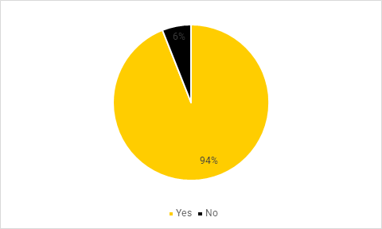

How do ITCP professionals describe their use of trauma-responsive and evidence-based practices, barriers to implementation, and future training needs?
Qualitative (see Table 1, below) and quantitative data were consistent in identifying the use of specific evidence-based therapeutic modalities such as Parent-Child Interaction Therapy (PCIT), Child-Parent Psychotherapy (CPP), Cognitive Behavioral Therapy (CBT), and trauma-informed interventions. Respondents also reported applying trauma-responsive principles across roles, even when not engaged in direct practice. Respondents emphasized the need for continued interdisciplinary collaboration, shared understanding across legal and clinical roles, and training focused on equitable and trauma-informed decision-making. Some commonly identified barriers to sustaining trauma responsive and evidence-based practice included:
- Limited availability of trained providers
- High turnover in child welfare positions
- Time constraints and workload demands
- Transportation and engagement challenges for families
- Variation in cross-disciplinary understanding of trauma-responsive practice
Qualitative findings in FY2025 were generally consistent with those from FY2024 when respondents also described using a range of therapeutic modalities and trauma-responsive approaches while identifying workforce limitations, provider shortages, and different understanding of trauma-informed practice across disciplines as perceived barriers. The FY2025 results suggested respondents emphasized a need for interdisciplinary collaboration, shared decision-making, and practical implementation challenges.
Table 1. What types of evidence-based and/or trauma-responsive practices do you use in working with ITCP?
Theme | Description | Exemplary Quote
Therapeutic Modalities | Respondents listed evidence-based interventions including Trauma Informed Care, Parents As Teachers, Nurturing Parenting Program, Child Parent Psychotherapy, Reflective Consultation, Parent Child Visitation, 24/7 Dads, Strengths Based Case Management, Motivational Interviewing, Head Start, Safe Care, Play Therapy, Theraplay, EMDR, Parent Partners, FFMs, Caring Dads, and working with specialty courts. | “Parent partners, FFMs, SafeCare, Caring Dads, and specialty courts are all examples of evidence-based practice we use.”
General Supports | General professional supports, such as therapists who specialize in trauma-based therapy were mentioned. | In general, “the ability to have more staffings and professional collaboration on cases, and meeting more frequently” provided support.
Organizational Practices | Respondents mentioned that, as an organization, they use evidence-based practices for their services. | “HHS only incorporates evidence-based practice into services.”
Note. Seven (7) responded to this question.

Table 2. What barriers do you encounter when implementing trauma-responsive or evidence-based practices?
Theme | Description | Exemplary Quote
Workforce Limitations | Respondents reported not having enough time to implement practices and to devote to case consultation. Respondents also mentioned that the waitlist for services can be long and that there is a shortage of providers for services. | “There are also not enough providers in the state to make evidence-based practice available to everyone who needs it.”
Client-Related Barriers | Respondents describe that there can be a lack of engagement and communication from parents and an unwillingness to share information. | “Parents that are stuck and not willing to engage in services.”
Lack of Awareness, Understanding, and Support | Respondents reported that barriers included a lack of buy-in from all providers, foster homes that support this model, and housing and therapists, especially CPP. A lack of awareness of the impact of removal was also reported. | “Not everyone is aware of the impact of removal on infants in the system.”
Note. 7 respondents answered this question. Themes align with both 2025 stakeholder survey responses and leadership focus group discussions.

Table 3. What areas should trauma-informed trainings focus on to address your professional needs?
Theme | Description | Exemplary Quote
Implementation and Outcomes | Respondents said that they would like to focus on the practical implementation of skills taught in trainings and how trauma-informed practices improve outcomes in child welfare proceedings. | “I think a big focus needs to be on how to adequately address concerns with parents in a trauma-informed manner. Sometimes, I think it is difficult to have discussions about concerns because we are trauma informed and don't want to re-traumatize the parent when bringing up these concerns. There has to be a healthy balance as not addressing concerns when they happen is ultimately a disservice to the family and professionals.”
Topic Areas | Respondents mentioned several specific topic areas to focus on including mental health services for children, parenting education, social services, homelessness, and legal issues.
Note. Five (5) respondents answered this question. Themes reflect triangulation of survey open-ended responses and October 2025 leadership discussions.

Summary of Trauma-Responsive and Evidence-Based Findings

Overall, 2025 results show support for local integration of trauma-responsive principles across agencies and sustained organizational commitment of agencies to evidence-based practice. Resource limitations and system-level constraints were cited as hinderances to consistent implementation. These results are consistent with the previous evaluation results and suggest that continued investment in workforce capacity, interdisciplinary training, and provider capacity for availability to engage in these activities will be essential to sustaining and strengthening ITCP implementation (Bunting et al., 2019).

State Leadership
In October 2025, members of the State Advisory Leadership Team (SALT) participated in an embedded evaluation session during a scheduled meeting. Leadership participants completed a brief six-item Likert survey (n = 13) and engaged in structured small-group discussions aligned with workforce representation, applicant outreach, and family participation research questions. This method replaced the prior stand-alone survey model and resulted in higher engagement and improved qualitative insight.

Workforce Representation and Recruitment
Survey findings suggest moderate agreement regarding inclusive hiring practices. Thirty-eight percent (38%) of respondents agreed that hiring practices encourage recruitment from a wide range of backgrounds, and half of respondents (54%) selected neutral responses. Forty-six percent (46%) reported promotions were based on transparent criteria, and 38% reported that the current workforce reflects the demographic characteristics of families served, while 38% indicated disagreement that the workforce is reflective of the service population (Figure 6).
Figure 6. Workforce Representation and Recruitment Survey Results (n = 13)
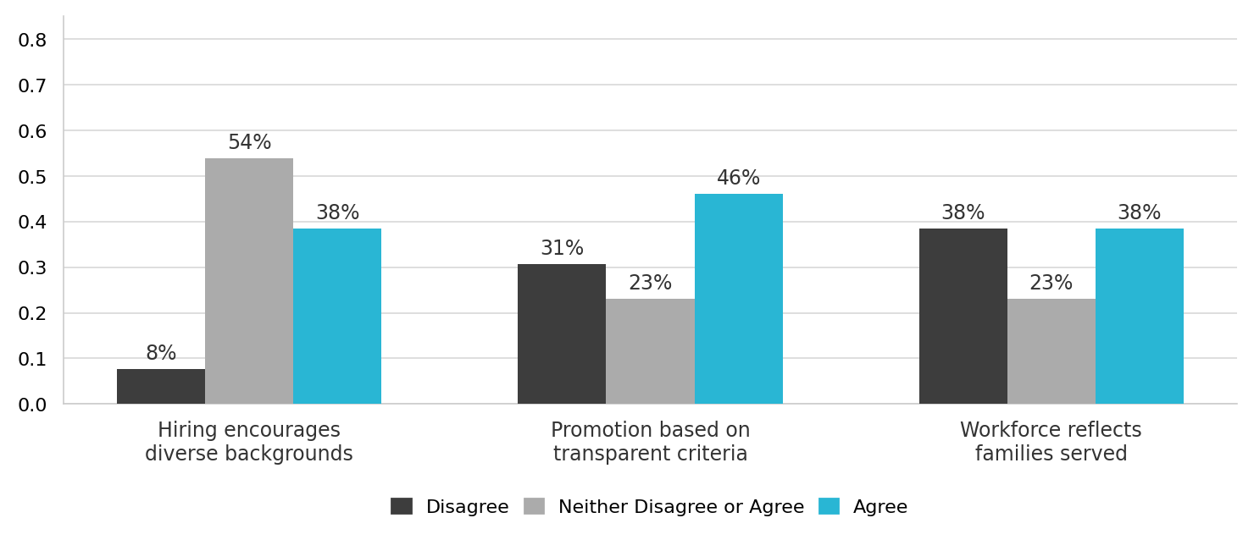
Information obtained through discussion reinforced the importance of valuing lived experience combined with formal education in recruitment decisions. Leadership participants emphasized the need to:
- Broaden qualifications (e.g., combining associate degrees with lived experience)
- Securing stable funding to retain workforce
- Offering reflective consultation to prevent burnout
- Maintaining diversity of professional roles and perspectives across teams

FY2025 findings were consistent with those from FY2024 in highlighting ongoing concerns about workforce diversity and recruitment. In both years, respondents noted that overall ITCP agencies and staff were not representative of the families served and emphasized the need to broaden applicant pools and strengthen inclusive hiring practices. These results suggest a need for shared commitment to representation, coupled with recognition that further structural alignment is needed.

Applicant Outreach and Workforce Capacity
Leadership discussions highlighted workforce capacity as a primary system constraint. Participants reported limited availability of attorneys for clients and increasing time demands of the Safe Babies approach relative to traditional court processes.
Survey responses regarding outreach challenges (Figure 7), indicated 17% agreed that applicants encountered challenges. Qualitative results suggested some concern about workload demands and the need for more clear communication between meetings. To address the concern, participants expressed interest in:
- More intentional use of leadership time
- Clearer differentiation between informational and action-oriented agenda items
- Structured mechanisms for contributing between meetings
Leadership also emphasized that the Safe Babies approach is adaptable and may allow for hybrid or flexible implementation approaches, particularly in rural areas.
Figure 7. Applicant Outreach and Workforce Capacity Survey Results (n = 12)
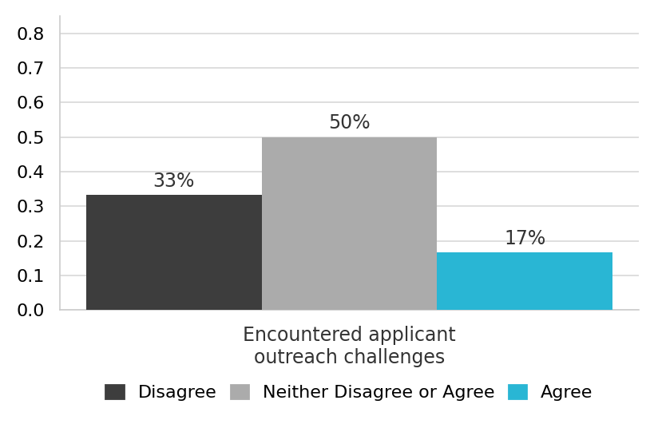

Equity in Family Participation
Family participation criteria emerged as one of the more important quantitative results. Of the leadership respondents 38% agreed that eligibility criteria are clear; in contrast 54% disagreed (Figure 8).
Figure 8. Equity in Family Participation Survey Results (n = 13)
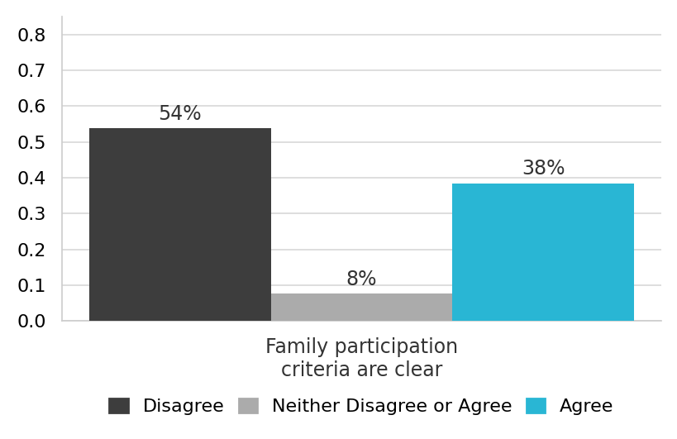
Qualitative discussions revealed that the referral pathway has evolved over time. While referrals were initially designed to flow through specific HHS administrative channels, referrals now occur through multiple pathways, including legal partners and supervisory consultation. Leadership expressed differing opinions about this evolution, some suggested it was problematic and others did not; however, participants agreed that greater clarity and documentation of the referral process would be helpful and would strengthen transparency and consistency of those served. Table 4 presents some of the qualitative results.

Table 1. Who determines which families participate in Safe Babies?
Decision Point | Description | Leadership Insight
Initial Identification | Families are identified through multiple referral pathways, including legal partners (judges and attorneys), child welfare supervisors, and court team members. | “Referrals are not always coming through the original pathway we outlined a few years ago.”
Administrative Review | HHS administrators and court team members may review eligibility based on child age, removal status, and court involvement. | “The process has evolved. It’s not necessarily good or bad, but it isn’t always consistent.”
Judicial Influence | Judges may influence participation decisions based on perceived case appropriateness, service availability, or team capacity. | “Sometimes it depends on what the team can realistically take on.”
Team Capacity Considerations | Workforce limitations and attorney availability influence whether a case can be accepted. | “The Safe Babies model requires more time than traditional services, and our teams are at capacity.”
Case Complexity | Families served often present with high levels of trauma, substance use, intellectual disability, or multi-system involvement. | “We tend to take very complex cases, which may influence permanency outcomes.”
Equity Considerations | Leadership acknowledged the importance of avoiding bias in selection and ensuring participation is not skewed toward families perceived as easier to engage. | “We need to make sure we’re not only serving families who seem easiest to work with.”
Need for Clarification | Only 38% of leadership respondents agreed that eligibility criteria are clear. | “We may need to refine and document the criteria more clearly moving forward.”
Note. Themes derive from the October 2025 SALT embedded survey and breakout discussions (n = 13 leadership respondents).
Leadership discussed the increasing case complexity observed among families being served. Participants noted that Safe Babies frequently engages families with high levels of trauma exposure, substance use, intellectual disability, incarceration, and multi-system involvement. Some expressed concern that serving disproportionately high-complexity cases may influence permanency outcome rates, including termination of parental rights (TPR).
Additionally, leadership raised equity considerations regarding potential selection bias and emphasized the importance of ensuring that participation decisions are not inadvertently skewed toward families perceived as “easier cases.”
Findings from FY2025 were consistent with findings from FY2024 regarding family participation and eligibility determination. In FY2024, leadership respondents frequently expressed uncertainty about who determines which families participate and what factors affect eligibility. In FY2025, this concern was also evident, with 38% of leadership respondents agreeing that eligibility criteria are clear and qualitative discussion pointing to evolving and inconsistently documented referral pathways.

Perceived Leadership Support
Despite concerns regarding eligibility clarity and workforce capacity, more than two-thirds of respondents (69%) reported feeling supported by state leadership in carrying out their Safe Babies team responsibilities. This represents a significant organizational strength and provides a strong foundation for open and honest discussions about implementing system improvements including those identified through this evaluation (Figure 9).

Figure 9. Perceived Leadership Support Survey Results (n = 13)
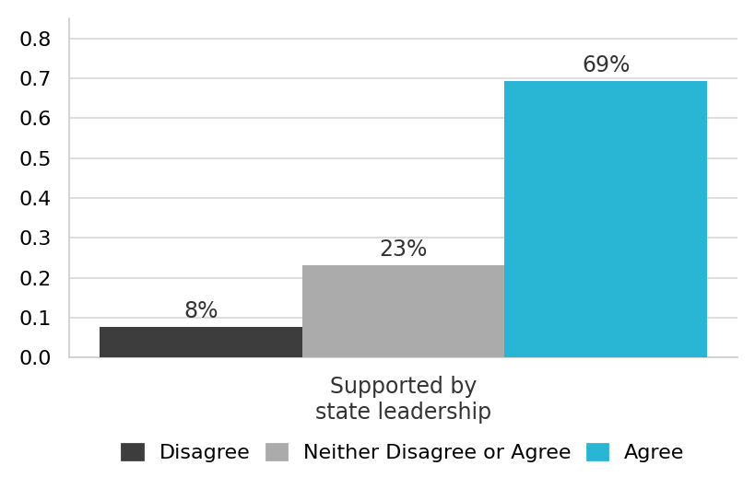

ITCP Permanency Outcomes
During the FY 2025 period (September 30, 2024 – September 29, 2025), a total of seven ITCP cases closed. Four cases ended with termination of parental rights (TPR), and three ended with reunification. This represents a TPR rate of 57% for FY2025, although the total number of cases is small. In all seven cases, the reason for removal was listed as neglect. Research using matched controls has shown that ITCT participation is associated with improved reunification rates and shorter time to permanency compared to similar cases not served by Safe Babies Court Teams (Stacks et al., 2025).
Table 2. Permanency Outcomes by Reason for Removal
Fiscal Year | Reason for Removal | Reunification | Termination of Parental Rights (TPR)
FY2024 | Neglect | 2 (20%) | 8 (80%)
FY2025 | Neglect | 3 (43%) | 4 (57%)
Note. FY2024 = September 30, 2023 – September 29, 2024; FY2025 = September 30, 2024 – September 29, 2025. The primary reason for removal was neglect (denial of critical care) in all cases.
Compared with FY2024, permanency outcomes improved modestly. In FY2024, 10 ITCP cases closed and 8 cases resulted in TPR, 2 resulted in reunification. The TPR rate for FY2024 was 80%. In FY2025, 7 cases closed and the number of TPR cases was four (4) with three (3) reunifications. These differences must be interpreted with caution because each year involves different and unique families, and the outcome data are limited by the small number of cases which reduces statistical power and increases the margin of error. In other words, due to the small sample size, the percentages reported are highly sensitive to individual variations. In a cohort of this size, a change in a single child’s outcome can shift the results by 10 to 14 percentage points, making the data more descriptive of this specific group than representative of a larger trend. Consequently, these percentages should be interpreted with caution.
Examining these results over a longer period of time would provide more robust results. Although the FY2025 TPR rate of 57% is lower than the 80% reported for FY2024, it remains higher than overall TPR rate for children ages 0–3 in Polk County, the State of Iowa, and national estimates. For example, in 2022, the TPR rate among Polk County cases involving children ages 0–3 was approximately 29.7% of founded reports.
Several factors may help explain the relatively high TPR rate in the past fiscal year. First, historically, high staff turnover at the Iowa Health and Human Services reduced ITCP’s operational capacity during FY2023 which reduced case closure in FY2023. With limited capacity, it is possible that the program served primarily the highest-need families, which may contribute to higher TPR rates.
Second, program administration and operational challenges may also play a role. Thematic analysis of open-ended survey responses from ITCP professionals identified barriers to implementing evidence-based and trauma-informed practices that may reduce TPR risk. These barriers included limited cohesion and collaboration across professionals, inconsistent understanding of trauma-informed practice across disciplines, and limited access to clinical or mental health professionals.
Third, the reason for removal in all cases was neglect, which is often associated with conditions related to poverty. Systemic or individual biases, combined with limited understanding of trauma-informed approaches, or under-identified organic factors (e.g., traumatic brain injury) may influence how neglect cases are assessed and addressed. As Merritt (2020) notes, “Policy revisions that mandate a nonjudgmental approach to supporting families are also warranted. For instance, if we arrive at a refined and universal definition of neglect that acknowledges the unintentionality of experiencing poverty, then our assessments about parenting will be based on compassion and empathy and will be less accusatory.”

CONCLUSIONS AND RECOMMENDATIONS
Findings and Key Takeaways from the Initial Survey Responses
Although response patterns should still be interpreted cautiously, FY2025 findings offer a clearer picture of implementation than FY2024 due to revised data collection methods and stronger leadership engagement. Findings from both years were generally consistent and the convergence of multiple data points provides a strong foundation for optimism regarding the intervention’s long-term outcomes. The data indicate sustained organizational commitment to trauma-informed and evidence-based practice which serve as a strong foundation to build on to address the persistent challenges related to workforce capacity, provider availability, family selection clarity, and cross-disciplinary collaboration.
- High Confidence and Organizational Support for Trauma-Responsive and Evidence-Based Practices
  - Respondents consistently reported high levels of experience with trauma-responsive and evidence-based practices. In FY2025, perceived training and organizational support for evidence-based practices remained strong, although reported frequency of use declined compared with FY2024, suggesting that implementation barriers may be limiting application in practice.
  - Nearly all respondents (89%) reported prior experience using trauma-responsive or evidence-based practices.
  - Strong organizational support was reported by most respondents, with 89% indicating adequate training and organizational support for both trauma-responsive and evidence-based practices in FY2025.
  - Barriers such as workforce limitations, high turnover, and service accessibility challenges hinder the consistent implementation of these practices.
- Resource Gaps for Evidence-Based Practices
  - Perceived resource sufficiency is evident for both trauma-responsive and evidence-based practices. Evidence-based practices appear to lag behind trauma-responsive approaches, indicating that practical and structural supports remain insufficient for full implementation.
  - In FY2025, 50% of respondents felt there were sufficient resources available to implement evidence-based practices, and 78% for trauma-responsive approaches (in FY2024, the percentages were 39% and 57%, respectively).
  - This suggests that while trauma-responsive frameworks may be well-integrated into agencies, the financial, personnel, or training resources needed to fully implement evidence-based interventions may need attention.
- Workforce Challenges and Equity Issues
  - Respondents expressed concerns about limited provider availability and high turnover impacting service delivery.
  - The lack of workforce diversity within ITCP agencies was also identified as an issue.
  - Suggestions included broadening applicant pools to improve hiring and increasing training opportunities on equitable, trauma-informed care.
- Challenges in Family Participation and Eligibility Determination
  - Concerns about family selection and eligibility determination were consistent in both fiscal years. FY2024 responses reflected uncertainty about referral pathways and decision-making authority, and FY2025 findings reinforced the need for greater clarity, transparency, and documentation of eligibility criteria.
  - Some respondents were unsure about how families are selected for participation, indicating a potential need for greater transparency or standardized decision-making processes.
  - Child age and parental engagement were identified as primary eligibility factors, though responses suggest more clarity is needed in what other selection criteria are applied.
- Training Needs and Cross-Disciplinary Collaboration
  - A lack of shared understanding of trauma-responsive practices across disciplines was identified.
  - Some legal professionals may not fully integrate trauma-informed approaches when working with families.
  - Respondents called for collaborative problem-solving training and increased opportunities for case consultation across professions.
- Professional Development
  - Reports about professional skill development being affected by involvement in the Safe Babies approach suggests that Safe Babies continues to function as an important interdisciplinary learning and capacity-building structure for participating professionals.

Recommendations
To strengthen ITCP implementation based on ongoing evaluation, the following recommendations are proposed:
- Integrate Evaluation into Routine Meetings to improve familiarity with the evaluation process and capitalize on the availability of data for continuous quality improvement purposes
  - Better integration of evaluation may also serve to engage survey participation in future data collection efforts. Embedding systematic data collection into scheduled meetings, (e.g., focus groups, structured discussions) can also contribute to consensus building and improved decision-making.
  - Research suggests that integrating evaluations within routine work activities reduces burden and improves response rates.
- Conduct Focus Groups with Stakeholders and Leadership
  - Given the limited survey responses, follow-up focus groups should be conducted in early fall with both stakeholders and leadership teams.
  - These discussions will provide more robust qualitative insights into workforce diversity, family selection processes, and evidence-based practice implementation.
- Expand Training on Trauma-Informed Collaboration and Equity Practices
  - Interdisciplinary training should be prioritized to address barriers in cross-professional collaboration, especially between legal professionals, child welfare workers, and therapists.
  - Research suggests that specific training on racial equity and trauma-informed decision-making could help improve family engagement and workforce diversity.
- Enhance Transparency in Family Selection Criteria
  - Clarify and communicate the process for determining family eligibility to ITCP professionals, ensuring that all stakeholders understand how and why families are selected.
  - Developing a written framework or decision tree for decision-making about eligibility and intake could help clarify issues about participation.
- Advocate for Increased Resources to Support Evidence-Based Practices
  - Findings suggest a need for greater investment in provider training, funding for implementing evidence-based practices, and workforce stabilization efforts.
  - State and local leaders have the most access and could explore policy options for increasing provider capacity in trauma-focused interventions.

References
Joseph, J. et al. (2023) Child and family outcomes of the Safe Babies Court Team – A scoping review. Children and Youth Services Review 149. https://doi.org/10.1016/j.childyouth.2023.106956.
Zero to Three (2020). Located at www.zerotothree.org.
Connell, C. et al. (2019). Enhancing Capacity for Trauma-informed Care in Child Welfare: Impact of a Statewide Systems Change Initiative. Amer. Journal of Community Psychology. https://doi.org/10.1002/ajcp.12375.
Bunting, L. et al. (2019). Trauma Informed Child Welfare Systems—A Rapid Evidence Review. Int J Environ Res Public Health. 2019 Jul 3;16(13):2365. doi: 10.3390/ijerph16132365.

